AI-Powered Multi-Platform Management & Insights

Project Proposal



Supervisor
Dr. Muhammad Asif

Submitted by

Muhammad Umair
01-135221-039
Esha Zafar
01-135221-144

Department of Computer Science,
Bahria University, Islamabad.

6th January 2025

Introduction
Managing social media presence across multiple platforms is time-consuming and redundant for small and medium-sized businesses (SMBs) and individual content creators. Our project aims to solve this by providing an integrated platform that allows users to create, schedule, and publish posts (text, images, and videos) across multiple social media platforms with a single click. Additionally, the platform will provide analytics, cross-platform post comparison, AI-driven sentiment analysis, and engagement tracking to optimize social media strategies. By consolidating multiple tools into a single dashboard, users can efficiently manage their online presence without switching between different applications. The AI- driven insights will help users identify the best-performing content, enabling them to refine their strategies for higher engagement ^{[1]}.

Objective
  - To design and develop an intelligent social media management platform.
  - To streamline post publishing for improved efficiency.
  - To track engagement metrics to measure social media performance.
  - To perform cross-platform analysis for comprehensive insights.
  - To provide AI-driven sentiment insights to enhance content strategy.
  - To improve content strategy for small and medium-sized businesses (SMBs) and individual creators.

Problem Description

What is the Problem?
SMBs and content creators face significant challenges in managing their social media presence, including the time-consuming process of manually posting content across multiple platforms, the difficulty in tracking and analyzing performance metrics, and the lack of unified tools for engagement and community building. Additionally, gaining insights into audience sentiment and competitor activity is challenging, and the overwhelming amount of scattered data makes strategic decision-making difficult and determines which platform generates the highest engagement ^{[2]}.

Why is it Important?
- Saves time and effort by automating multi-platform posting.
- Enables data-driven decision-making by comparing post performance across platforms.
- Helps businesses and influencers optimize their social media strategies through engagement tracking and AI-driven insights.
- Allows users to maintain posting consistency with automated scheduling.

Methodology
- Platform Integration: Use social media APIs (Facebook, Instagram, YouTube, Twitter, LinkedIn, YouTube, TikTok) for automated posting and data retrieval.
- Cross-Platform Comparison: Implement analytical tools to compare engagement (likes, shares, comments, reach) across different platforms.
- Post Scheduling: Develop a scheduler allowing users to plan posts in advance.
- AI Sentiment Analysis: Use Natural Language Processing (NLP) models to analyze comments for positive, negative, and neutral sentiments.
- Gamification & Rewards: Implement badges and achievements to incentivize consistent engagement.
- Modularity & Extensions: Allow plugin compatibility with platforms like WordPress to extend functionality.

Project Scope
The platform will offer multi-platform posting, engagement tracking, analytics, AI-driven sentiment analysis, post scheduling, gamification. However, direct ads management, an influencer marketplace, deepfake detection, and automated comment replies are outside the scope of this project. It is assumed that APIs will provide the necessary data access and that the AI models will be trained with sufficient datasets.

Feasibility Study

Risks Involved:
- API limitations and rate restrictions.
- AI model accuracy for sentiment analysis.
- Data privacy concerns.

Resource Requirements:
  - Cloud-based backend for storing user data and analytics.
  - AI/ML tools for sentiment analysis (e.g., TensorFlow, OpenAI GPT-4) ^{[3]}.
  - Database for user management and post tracking.
  - Web development resources.

Solution Application Areas
- Digital Marketing Agencies: For handling multiple clients' social media presence.
- Small & Medium Businesses: To optimize brand engagement.
- Influencers & Content Creators: To manage, analyze, and grow their audience effectively.

Tools/Technology
- Frontend: React.js.
- Backend: Node.js, Express.js.
- Database: MongoDB (NoSQL).
- AI/ML: TensorFlow, OpenAI API, NLP libraries.
- Cloud & Deployment: AWS/Azure for hosting, Docker for containerization.
- Social Media Integration: Facebook Graph API, YouTube Data API, Twitter API, Instagram API.

Expertise of the Team Members
- Experience in full-stack development (React, Node.js, MongoDB).
- Proficiency in Tailwind CSS and Material UI for frontend styling.
- Knowledge of RESTful APIs and third-party integrations.
- Basic understanding of AI/ML for sentiment analysis.
- Experience with cloud hosting (AWS/Azure) and Docker for deployment.

10. Milestones
- Phase 1: Research and API integration.
- Phase 2: UI/UX development & Post scheduling feature.
- Phase 3: Cross-platform analytics & AI Sentiment Analysis.
- Phase 4: Gamification features & AI content recommendations.
- Phase 5: Testing, debugging, and deployment.

11. Database Schema (Mongodb)
- User Collection
Field Name | Data Type | Description
_id | ObjectId | Unique identifier for the user
name | String | User's name
email | String | User's email (unique)
password | String | User's hashed password
role | String | User's role (e.g., 'user', 'admin')
profilePic | String | URL to user's profile picture
socialMediaAccounts | Array | List of social media accounts linked
- Post Collection
Field Name | Data Type | Description
_id | ObjectId | Unique identifier for the post
content | String | Content of the post (text, image, video)
platform | Array | List of platforms (e.g., 'Facebook', 'Instagram')
status | String | Post status ('draft', 'scheduled', 'published')
scheduledTime | Date | Time the post is scheduled to be published
postIdFromPlatform | String | Post ID from the respective platform API
engagementMetrics | Object | Metrics (likes, comments, shares, reach)
sentimentAnalysis | Object | Sentiment analysis results (positive, neutral, negative)
createdAt | Date | Date the post was created

- Analytics Collection
Field Name | Data Type | Description
_id | ObjectId | Unique identifier for the analytics record
postId | ObjectId | Reference to the Post collection
platform | String | Platform where post is published
likes | Number | Number of likes on the post
comments | Number | Number of comments on the post
shares | Number | Number of shares on the post
reach | Number | Reach of the post (impressions)
timestamp | Date | Date and time when the analytics were recorded
- Sentiment Analysis Collection
Field Name | Data Type | Description
_id | ObjectId | Unique identifier for the sentiment record
postId | ObjectId | Reference to the Post collection
sentiment | String | Type of sentiment ('positive', 'negative', 'neutral')
score | Number | Sentiment score (e.g., sentiment analysis score)
analysisTimestamp | Date | Timestamp of when the sentiment analysis was performed.
- Achievement Collection
Field Name | Data Type | Description
_id | ObjectId | Unique identifier for the achievement record
userId | ObjectId | Reference to the User collection
badge | String | Name of the badge or achievement
points | Number | Points awarded for the achievement
timestamp | Date | Date when the achievement was awarded
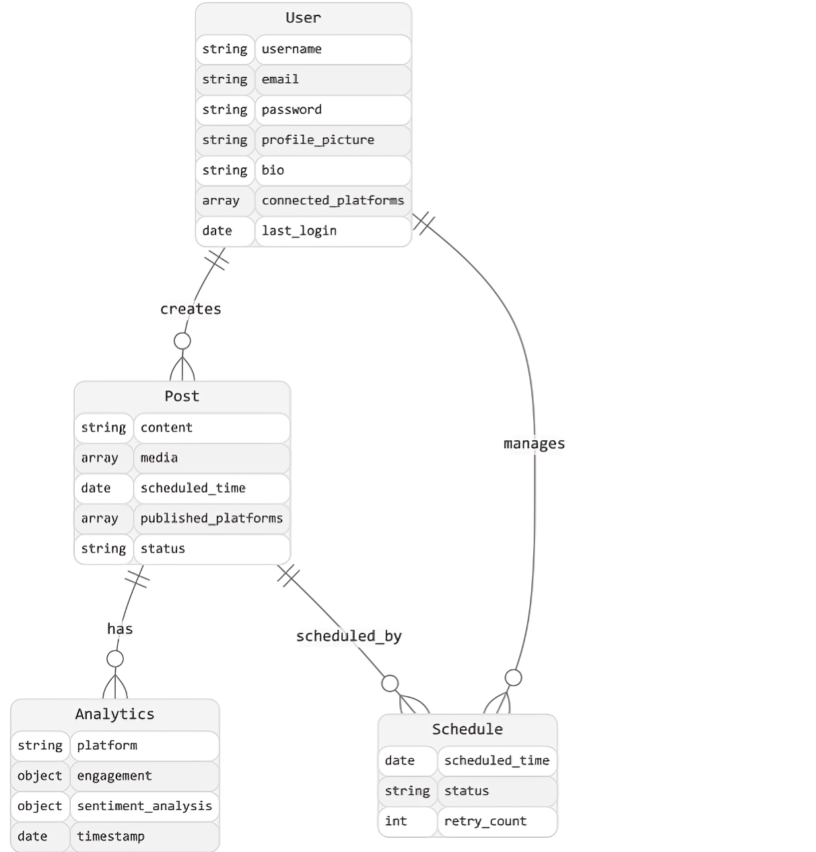

12.Flow Chart
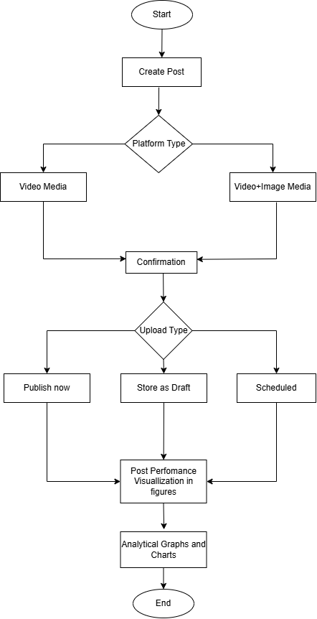

13.Existing Software
Feature | Buffer | Hootsuite | SocialPilot | Sprout Social | Keyhole | Brandwatch | SocialSight
Post Scheduling | ✔️ | ✔️ | ✔️ | ✔️ | ✔️ | ✔️ | ✔️
Social Media Monitoring | ❌ | ✔️ | ✔️ | ✔️ | ✔️ | ✔️ | ✔️
Analytics & Reporting | ✔️ | ✔️ | ✔️ | ✔️ | ✔️ | ✔️ | ✔️
Team Collaboration | ✔️ | ✔️ | ✔️ | ✔️ | ❌ | ✔️ | ❌
Content Calendar | ✔️ | ✔️ | ✔️ | ✔️ | ❌ | ✔️ | ✔️
Social Listening | ❌ | ✔️ | ❌ | ✔️ | ✔️ | ✔️ | ❌
CRM Integration | ❌ | ❌ | ❌ | ✔️ | ❌ | ❌ | ❌
Ads Campaign Management | ❌ | ✔️ | ❌ | ❌ | ❌ | ❌ | ❌
Sentimental Analysis | ❌ | ❌ | ❌ | ❌ | ❌ | ❌ | ✔️
Post Cross Comparison | ❌ | ❌ | ❌ | ❌ | ❌ | ❌ | ✔️

14.References
- "Facebook Graph API Documentation." Meta for Developers, 2024, https://developers.facebook.com/docs/graph-api/.
- "YouTube Data API." Google Developers, 2024, https://developers.google.com/youtube/v3/.
- "Natural Language Processing with TensorFlow." Google AI Blog, 2024, https://research.google/blog/.
- Vayadande, K., Gejage, V., Gaikwad, R., Gangode, S., Gadekar, A. and Ghavate, S., 2024, June. Navigating Tomorrow’s Engagement: A Comprehensive Social Media Management Platform. In 2024 Second International Conference on Inventive Computing and Informatics (ICICI) (pp. 73-79). IEEE.
- Benthaus, J., Risius, M. and Beck, R., 2016. Social media management strategies for organizational impression management and their effect on public perception. The Journal of Strategic Information Systems, 25(2), pp.127-139.
- Shahbaznezhad, H., Dolan, R. and Rashidirad, M., 2021. The role of social media content format and platform in users’ engagement behavior. Journal of Interactive Marketing, 53(1), pp.47-65.
- Kordzadeh, N. and Young, D.K., 2022. How social media analytics can inform content strategies. Journal of Computer Information Systems, 62(1), pp.128-140.
- "Social Media Sentiment Analysis Dataset." Kaggle, February 17, 2025, https://www.kaggle.com/datasets/abdullah0a/social-media-sentiment-analysis-dataset.

